**KHWOPA ENGINEERING COLLEGE**

**(Affiliated to Purbanchal University)**

**Libali, Bhaktapur**



**[Subject Code: BEG278CO]**

**A PROJECT REPORT**

**ON**

**HOSPITAL MANAGEMENT SYSTEM**

**Submitted by**

Anurag Paudel [760305]

Ashal Upreti [760307]

Madan Acharya [760321]

Sujan Dhoj Karki [760342]

**A MINOR PROJECT SUBMITTED IN PARTIAL FULFILLMENT OF THE REQUIREMENT FOR THE DEGREE OF BACHELOR IN COMPUTER ENGINEERING**

**Submitted to**

**Department of Computer Engineering**

**February, 2022**

**Supervised by**

**Avijit Karn**

**KHWOPA ENGINEERING COLLEGE**

**DEPARTMENT OF COMPUTER ENGINEERING**

**APPROVAL LETTER**

The undersigned certify that they have read and recommended to the Institute of Engineering for acceptance, a project report entitled “HOSPITAL MANAGEMENT SYSTEM” submitted by Anurag Paudel, Ashal Upreti, Madan Aacharya and Sujan Dhoj Karki in partial fulfillment for the degree of Bachelor of Engineering in Computer Engineering.

**Panel of Examiners:**

**Name Signature Date**

**External examiner**

**..………………… ………………………. …………………..**

**Project Supervisor**

**Er. Avijit Karn ………………………. …………………..**

**Head of Department**

**Er. Bikash Kumar Chawal ………………………. …………………..**

# ACKNOWLEDGEMENT

In performing our project, we had to take help and guidelines of some respected persons, who deserve our greatest gratitude. We would like to express our deepest gratitude to **Er. Avijit Karn** for his guidance and supervision and thank him for providing the information and resources required for this project and also would like to express our gratitude to **Er. Bikash Chawal** (HOD) Department of Computer Engineering of Khwopa Engineering College**.** We would like to thank our friends, seniors, and all those who have been guiding and helping us indirectly for the completion of project.

# ABSTRACT

The purpose of this study is to develop a simple Hospital Management System that will remove some paper works. The study was able to produce the module that will store hospital detail, staff detail, patient detail, work schedule and attendance. Furthermore, the study used the waterfall methodology that follow a linear structure starting from preliminaries investigation, required analysis, design and implementation. The interface is user friendly.

**LISTS OF FIGURES**

|  |  |  |
| --- | --- | --- |
| **Figure No.** | **Name** | **Page No** |
| Fig. 4.1 | Context Diagram | 05 |
| Fig. 4.2 | Generic Model | 06 |
| Fig. 4.3 | Use Case Model | 07 |
| Fig. 4.4 | Flowchart | 09 |
| Fig. 5.1 | Welcome Screen | 13 |
| Fig. 5.2 | Login Screen | 14 |
| Fig. 5.3 | Main Screen | 14 |
| Fig. 5.4 | Add Data Screen | 15 |
| Fig. 5.5 | View Data Screen | 15 |
| Fig. 5.6 | Update Data Screen | 16 |
| Fig. 5.7 | Delete Data Screen | 16 |
| Fig. 5.8 | Work schedule Screen | 17 |
| Fig. 5.9 | Hospital Detail Screen | 17 |
| Fig. 5.10 | Staff Detail Screen | 18 |
| Fig. 5.11 | Patients Detail Screen | 18 |

**TABLE OF CONTENTS**

|  |  |  |
| --- | --- | --- |
| Chapter | Title | Page |
|  | Approval Letter | i |
|  | Acknowledgement | ii |
|  | Abstract | iii |
|  | List of Figures | iv |
|  |  |  |
| 1 | Introduction |  |
|  | 1.1 Background | 1 |
|  | 1.2 Statement of Problem | 2 |
|  | 1.3 Objective | 2 |
|  | 1.4 Scope and Application | 2 |
|  | 1.5 Limitation | 2 |
|  |  |  |
| 2 | Literature Review | 3 |
|  |  |  |
| 3 | Project Management |  |
|  | 3.1 Team Management | 4 |
|  | 3.2 Feasibility Study | 4 |
|  |  |  |
| 4 | Methodology |  |
|  | 4.1 Context Diagram | 5 |
|  | 4.2 Generic Model | 6 |
|  | 4.3 Use Case Model | 7 |
|  | 4.3 Algorithm | 8 |
|  | 4.4 Flowchart | 9 |
|  | 4.6 Tools and Platform | 12 |
|  |  |  |
| 5 | Result |  |
|  | 5.1 Screenshot | 13 |
|  | 5.2 Conclusion | 19 |
|  |  |  |
| 6 | Reference | 20 |

**CHAPTER-1**

**INTRODUCTION**

# 1.1 Background

Hospitals deal with the life and health of their patients. Good medical care relies on well-trained doctors and nurses and on high quality facilities and equipment. Good medical care also relies on good record keeping. Without accurate, comprehensive and up to date and accessible patient notes, medical personnel may not offer the best treatment or may in fact misdiagnose the condition, which can have serious consequences. Associated records, such as x-rays, specimens, drug records and patient registers, must also be well cared for if the patient is to be protected. Good records care also ensures the hospitals administration runs smoothly; unneeded records are transferred or destroyed regularly, keeping storage areas clear and accessible; and key records can be found quickly, saving time and resources. Records also provide evidence of the hospital’s accountability for its actions and they form a key source of data for medical research, statistical reports and health information systems [1]**.**

Hospital Management system (HMS) is an integrated software that handles different directions of clinic workflows. In other words, HMS is a computer system that helps to manage the information related to health care and aids in the job completion of health care providers effectively. HMS came into the picture of hospital management as early as 1960 and have ever since been evolving and synchronizing with the technologies while modernizing healthcare facilities. In today’s world, the management of healthcare starts from the hands of the patients through their mobile phones and facilitates the needs of the patient. It manages the smooth healthcare performance along with administrative, medical, legal, and financial control, laboratory, inpatient, outpatient, materials, nursing, etc. That is a cornerstone for successful operation of the healthcare facility. Well-tuned hospital management workflow involves a lot of important decisions that should be made in the most efficient and quick way [2]**.**

We need Hospital Management systembecause an integrated Hospital Managementsystem will allow you to share patient health records and required tests with the laboratory.

**1.2 Statements of Problems:**

1. **Difficult to find data: -** In hospital sector with a lot of proper works it is difficult to find out data immediately.

E.g.: - Difficult to find out the patient’s history and late retrieval.

1. **Immediate information storage: -** In hospital sector there is no immediate information storage technique than paper works.
2. **Lack of updating: -** To change the details there will be so much difficulties in the paperwork. So, updating time to time is almost impossible.
3. **Time wasting management: -** Due to involvement in paperwork most of the hospital of Nepal has time wasting management system.

# 1.3 Objective:

# i) To make a simple hospital management system.

# 1.4 Scope and Application:

i) Helps to provide all information of staff and patients, time scheduling and attendance system.

**1.5 Limitation:**

i) It does not include all the sector of hospital system.

**CHAPTER-2**

# LITERATURE REVIEW

**Hospital Management system** streamlines and integrates the operations process and information flow in hospitals and is designed to manage all data through single interface [2]. It provides the ability to manage all proper works in one place reducing work to staff in every aspect. So, it mainly targets to reduce in work through easy record keeping interface [3].

It is mainly focus on the administrational needs of hospital that can achieve easily managing ability of hospital staff [4]. Hospital Management System generate the flexibility to staff and patients, keeping record of staffs as attendance and all records related them to solve the problems in Hospital sector.

The project dealing with computerization of services of Hospital is crucial part of our lives. It is essential to preserve track of its day-to-day action and records of its patients, doctor, nurses and other staff person that keeping hospital running smoothly and successfully [5]. Hospital Management System can control Billing management, Prescription management, Discharging, Lab management system and so on. Hospital Management System greatly changed over the last decade, modern technology, knowledge, health care helps to implement in system. Quality and security still remain the main criteria of the medical industry.

Through Hospital Management System each hospital sector has opportunity to create the efficient, clear and fast delivering healthcare model.

**CHAPTER-3**

**PROJECT MANAGEMENT**

# 3.1 Team Management

All the required efforts for this project were done by all of the four members of a team:

a) Anurag Paudel (760305)

1. Ashal Upreti (760307)
2. Madan Acharya (760321)
3. Sujan Dhoj Karki (760342)

# 3.2 Feasibility Study:

Our project aims to run a user-friendly hospital management system and expanding the features as requirements. This system doesn’t use any other additional software. It is cost effective in the sense that has eliminated paper work completely.

**3.3 Work Breakdown Structure:**

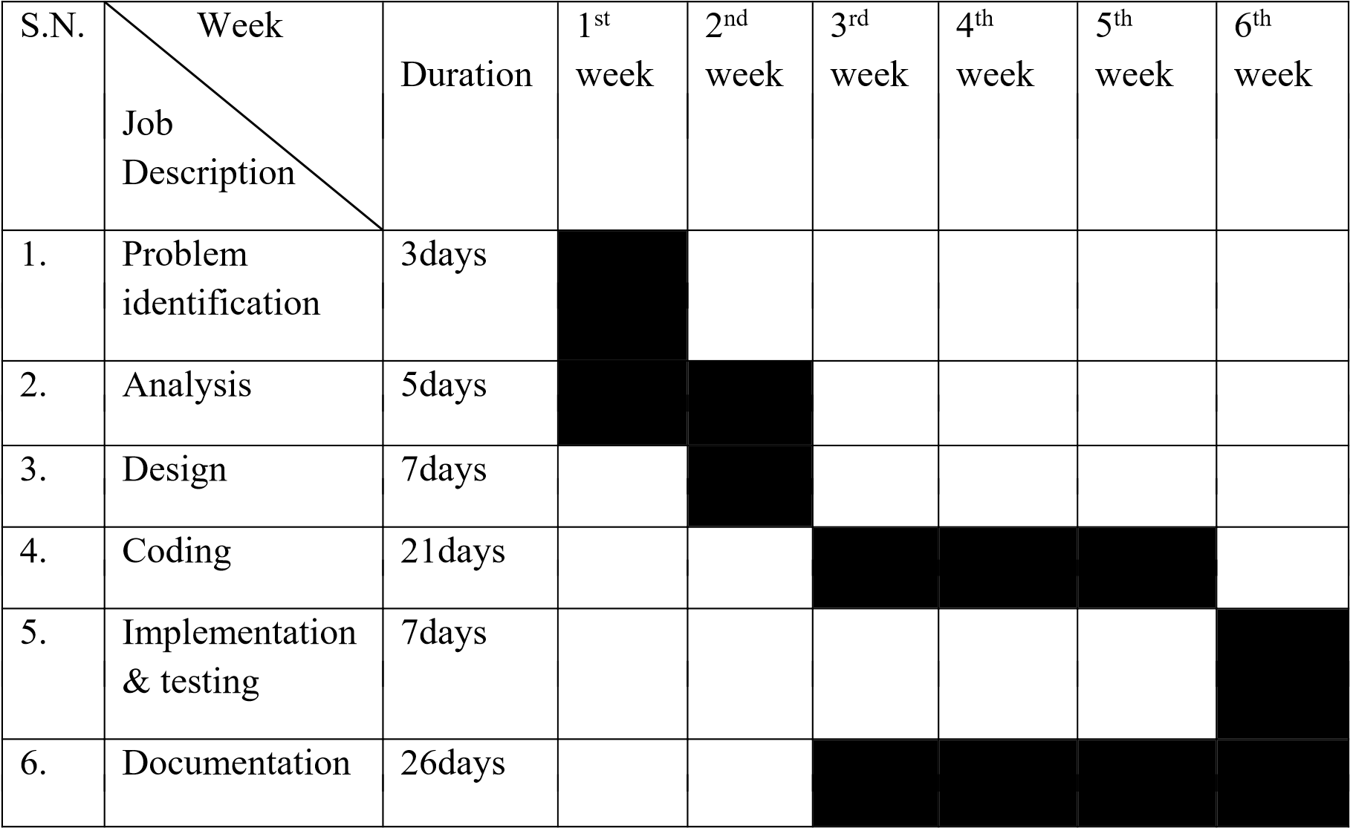

# CHAPTER-4 METHODOLOGY

**4 .1 Context Diagram:**

General staff

Add/Update Info

View

Fig 4.1: Context diagram

**4.2 Generic Model**

Store

Add details

Store

Edit details

Admin

View details

Delete details

Fig 4.2: Generic model

**4.3 Use Case Diagram:**

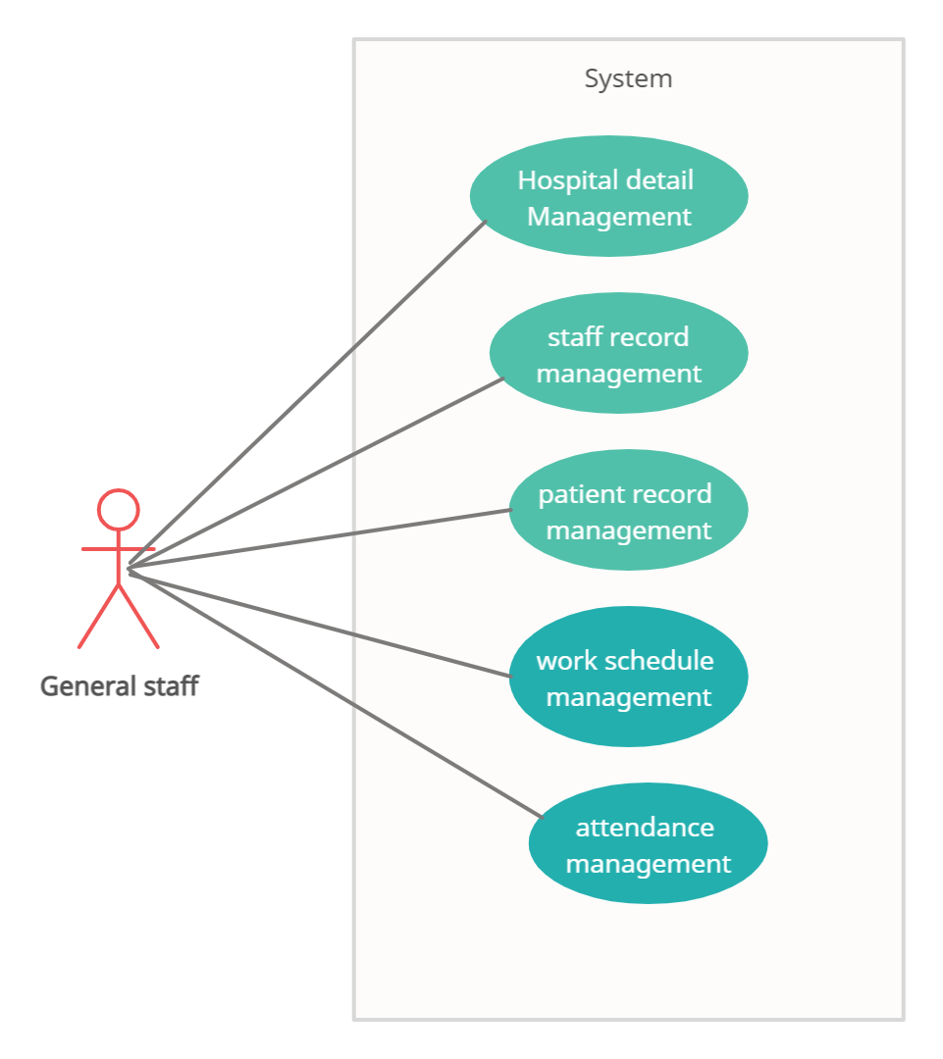

Fig 4.3: Use Case Diagram

# 4.4 Algorithm

Step 1: Start

Step 2: Enter the username and password.

Step 3: If username and password is valid and then declare variable character choice and print

1. Hospital detail.
2. Staff details.
3. Patient detail.
4. Work schedule.
5. Staff attendance.

Step 4: If choice is valid then go to further process and if invalid go to step 2. Step 5: If choice is made then show variable character choice and print

1. View detail.
2. Add detail.
3. Edit detail.
4. Update detail
5. Delete detail
6. Back

Step 6: If choice is valid go to further process and if invalid go to step 5.

Step 7: edit or add or view or delete details.

Step 8: If edited or added then store it and if viewed then go to further process and go to step 5.

Step 9: If choice is ‘f’ then goes to step 3

Step 10: end.

**4.5 Flowchart**

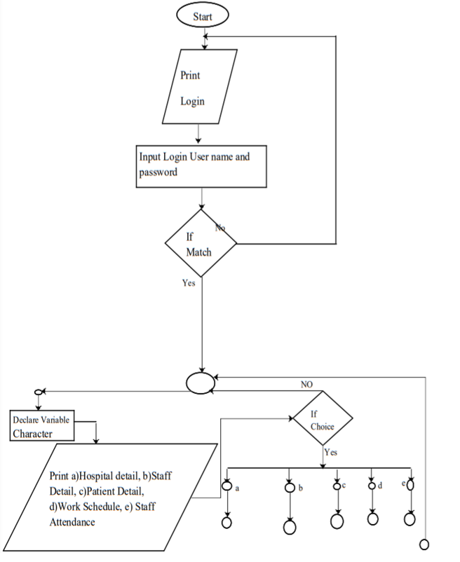

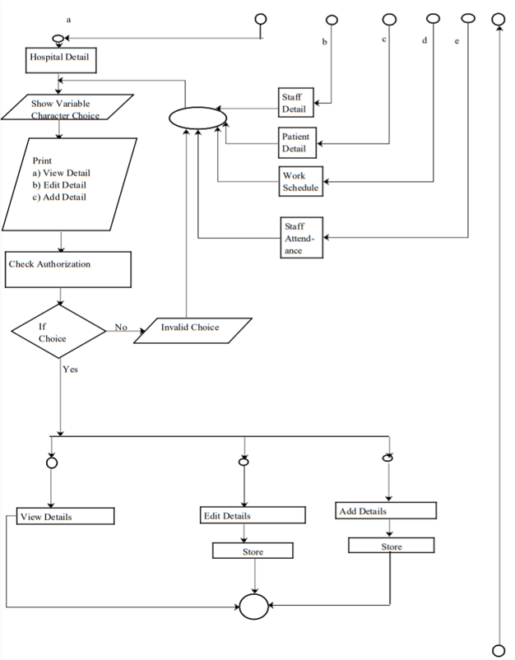

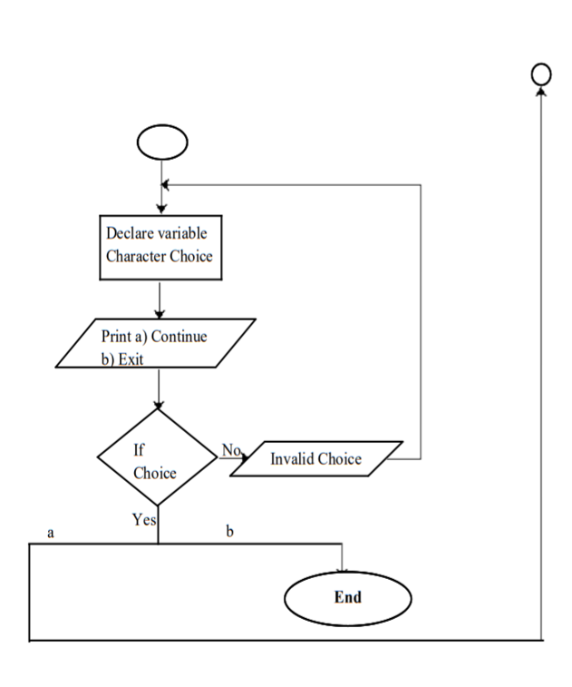

Fig 4.5: Flowchart

**4.6 Tools and Platform:**

Software: Dev C++

Platform: Windows

**CHAPTER-5**

**RESULT AND DISCUSSION**

**5.1 screenshots**

This system helps to records of doctors, nurses, patients and other staffs also their work schedule, attendance will be stored by user.

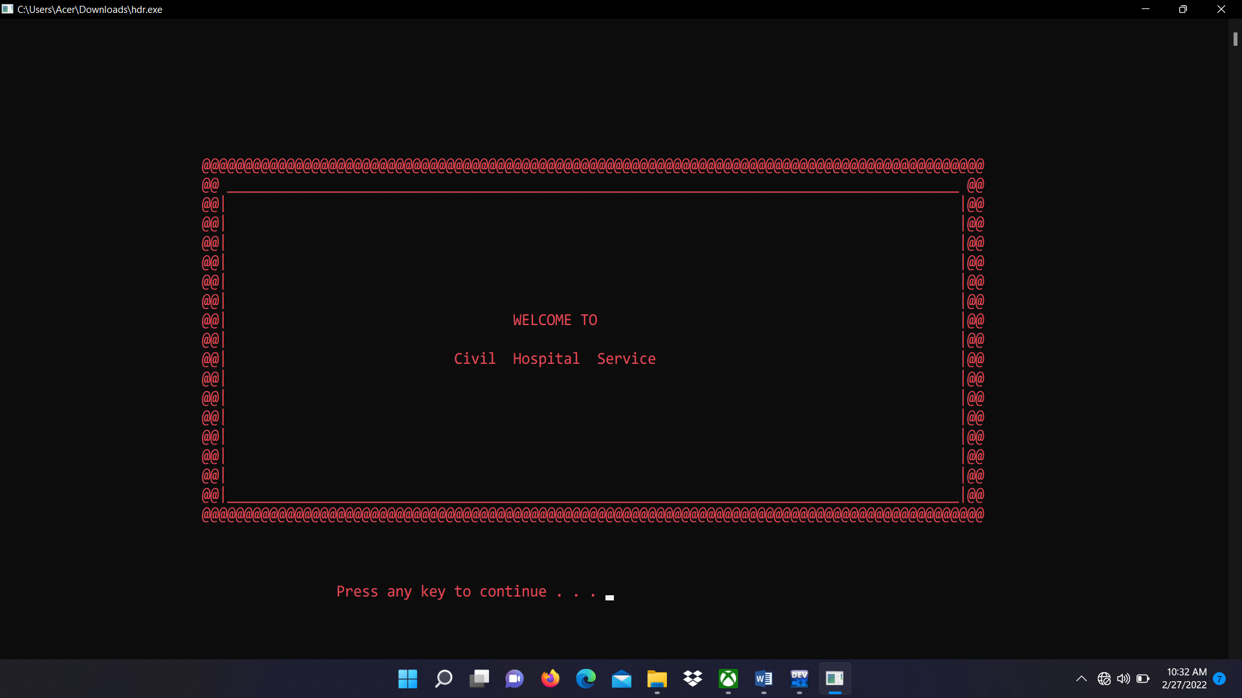

Fig 5.1: Welcome screen

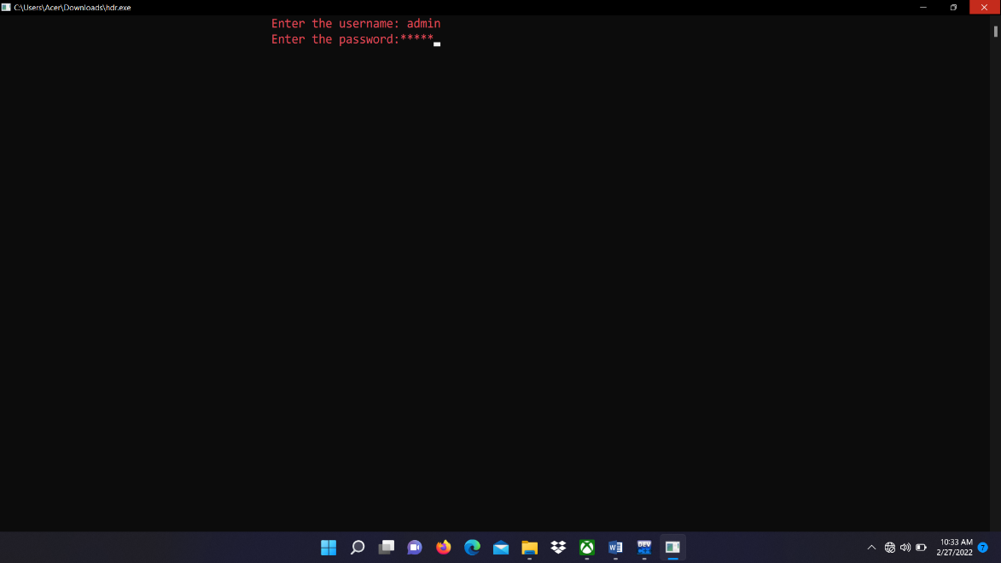

Fig 5.2: Login

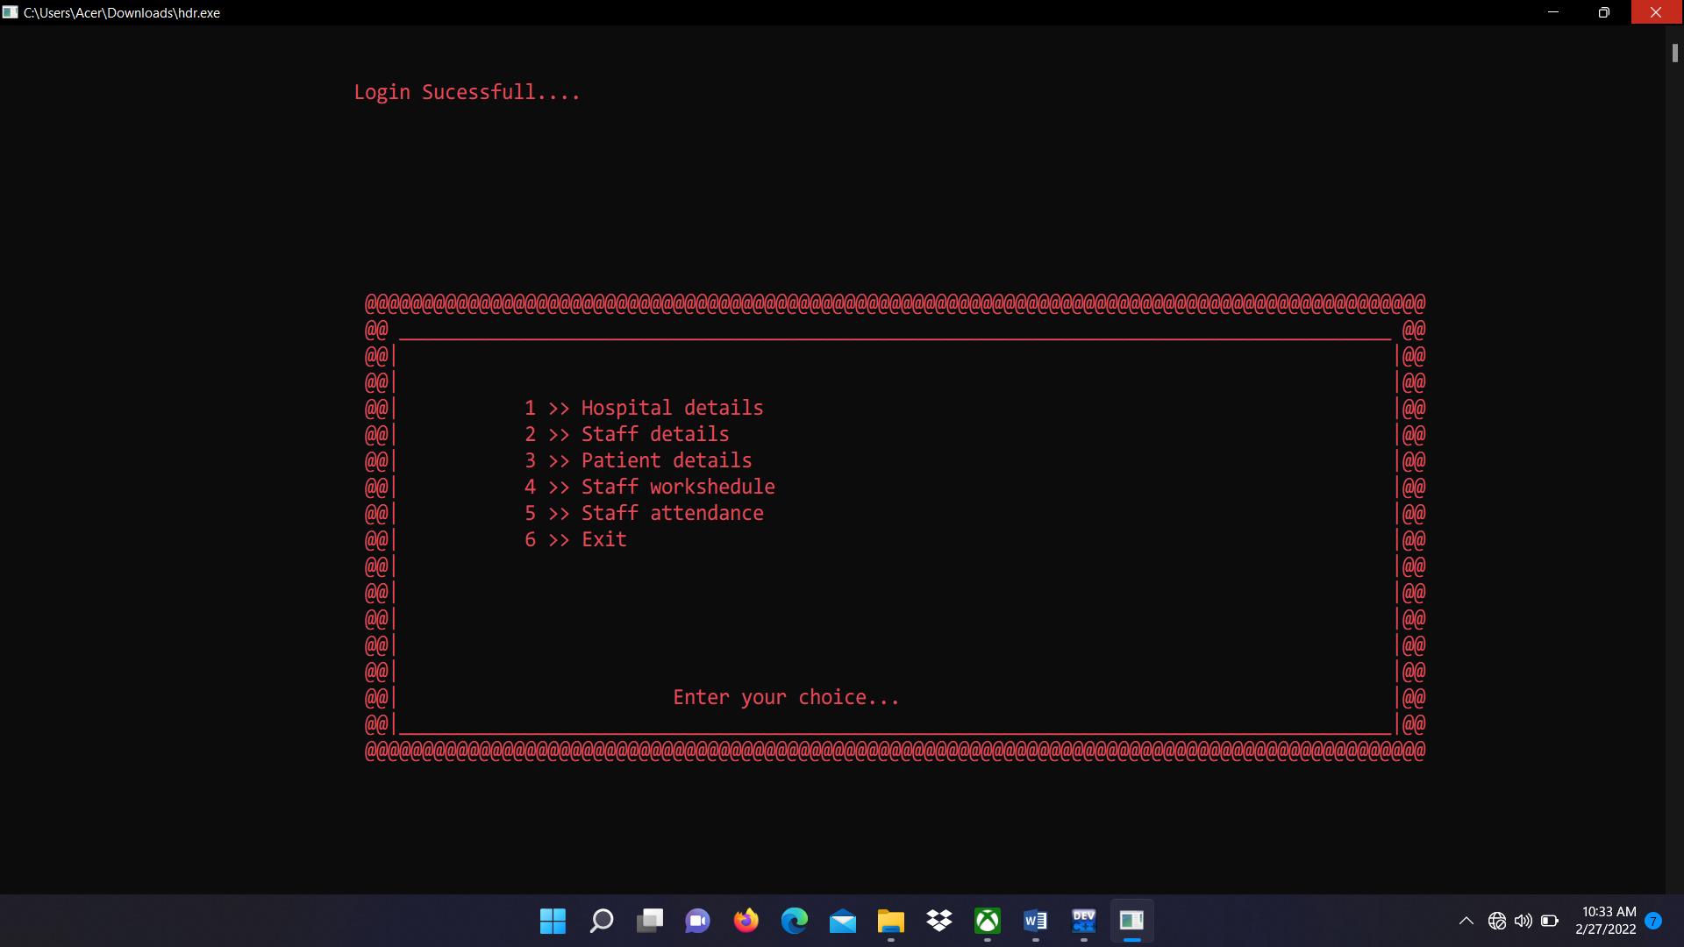

Fig 5.3: Main Screen

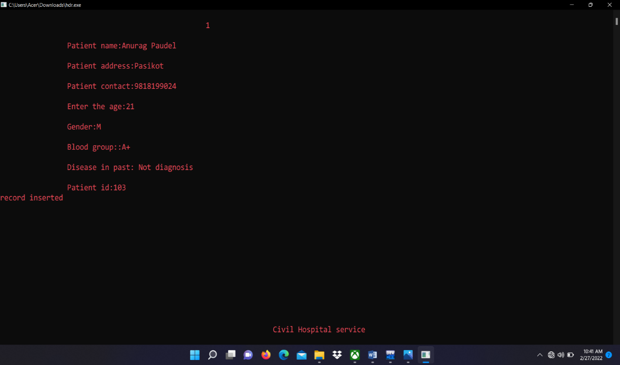

Fig 5.4: Add data Screen

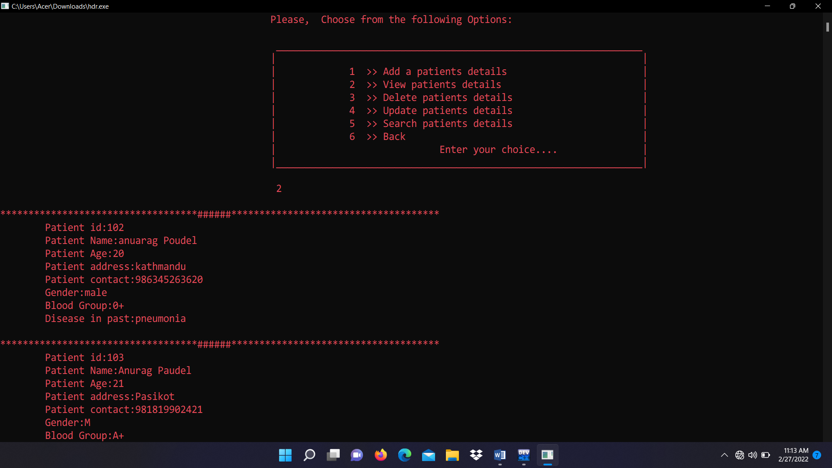

Fig 5.5: View Data Screen

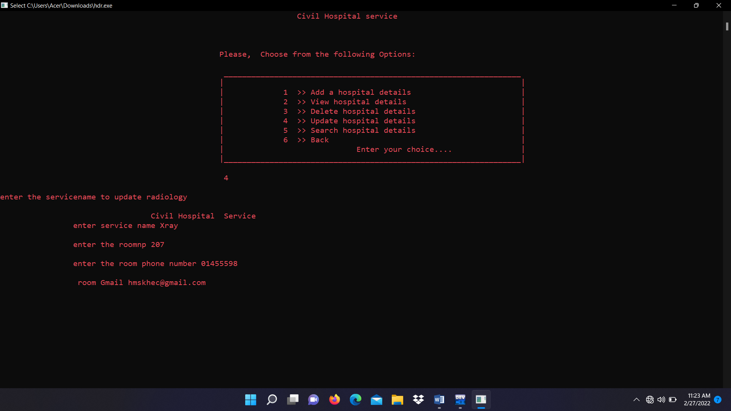

Fig 5.6: Update Data Screen

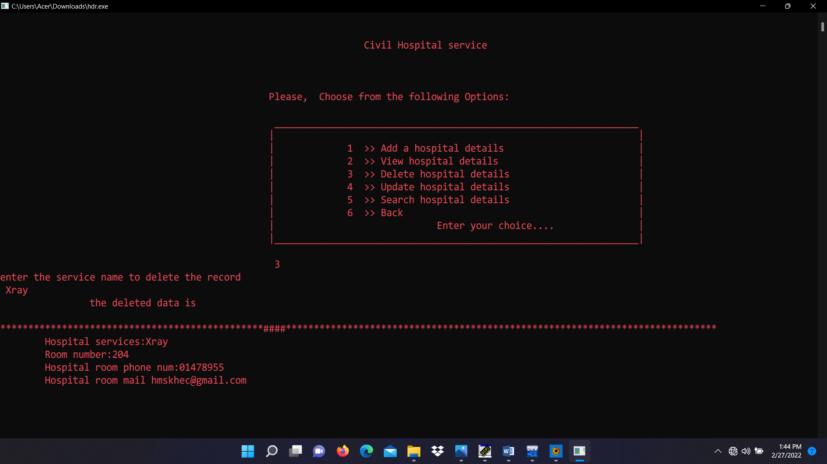

Fig 5.7: Delete Data Screen

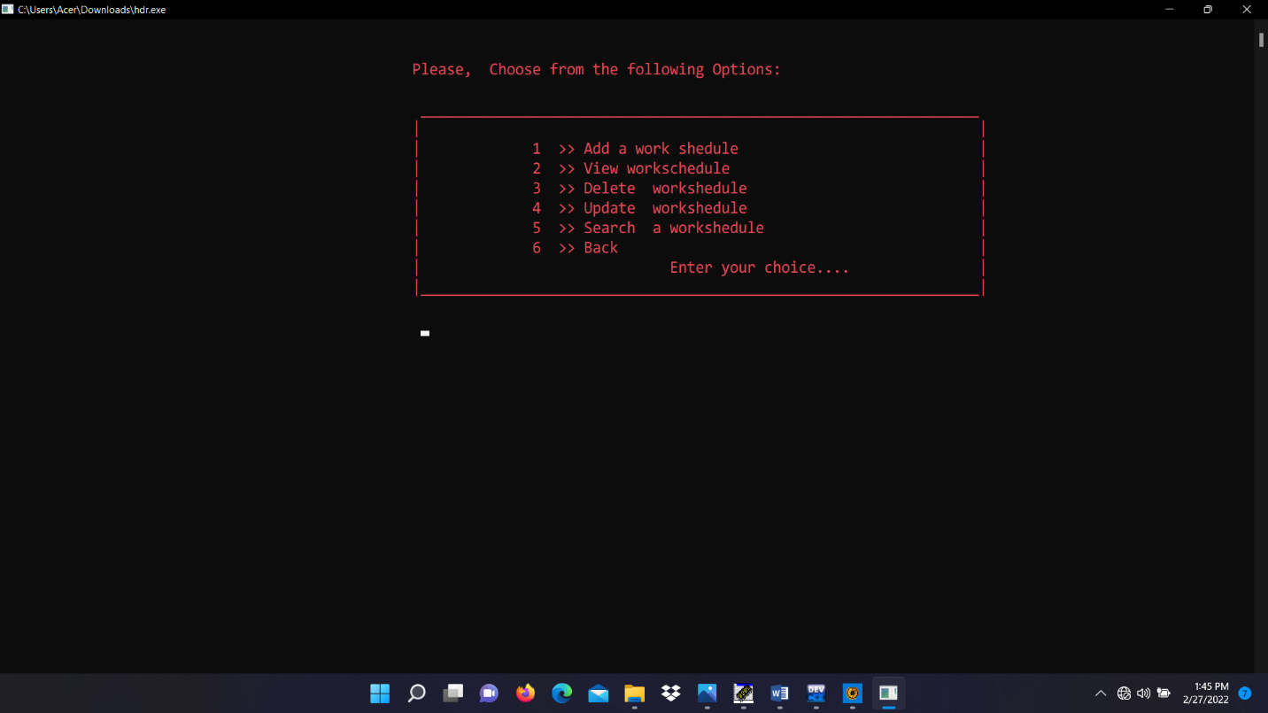

Fig 5.8: Work schedule screen

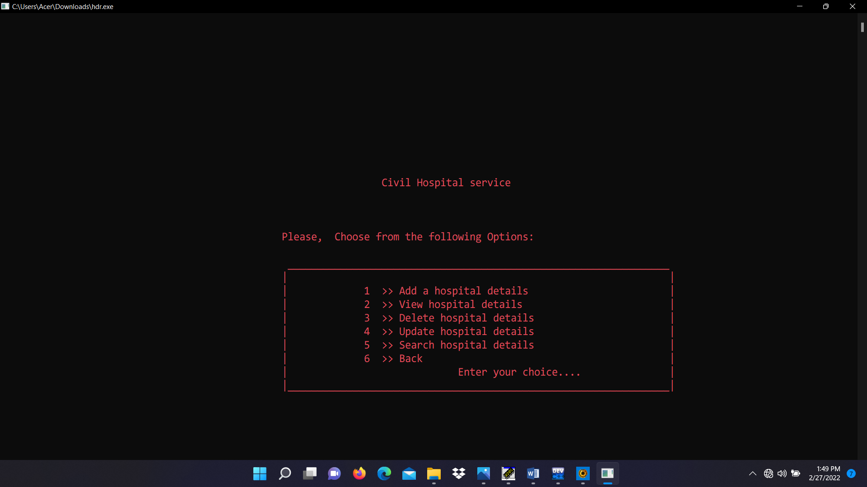

Fig: 5.9: Hospital Detail Screen

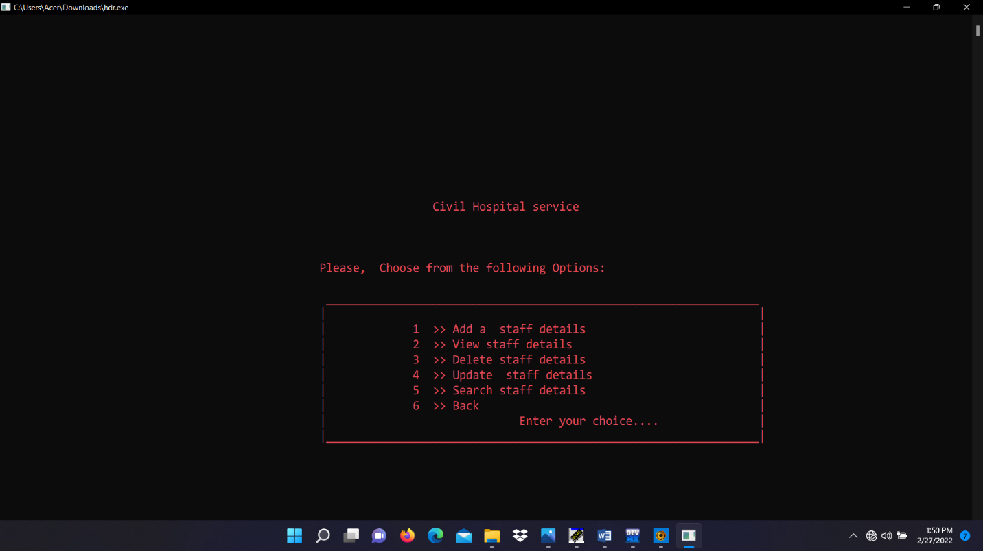

Fig: 5.10 Staff Detail Screen

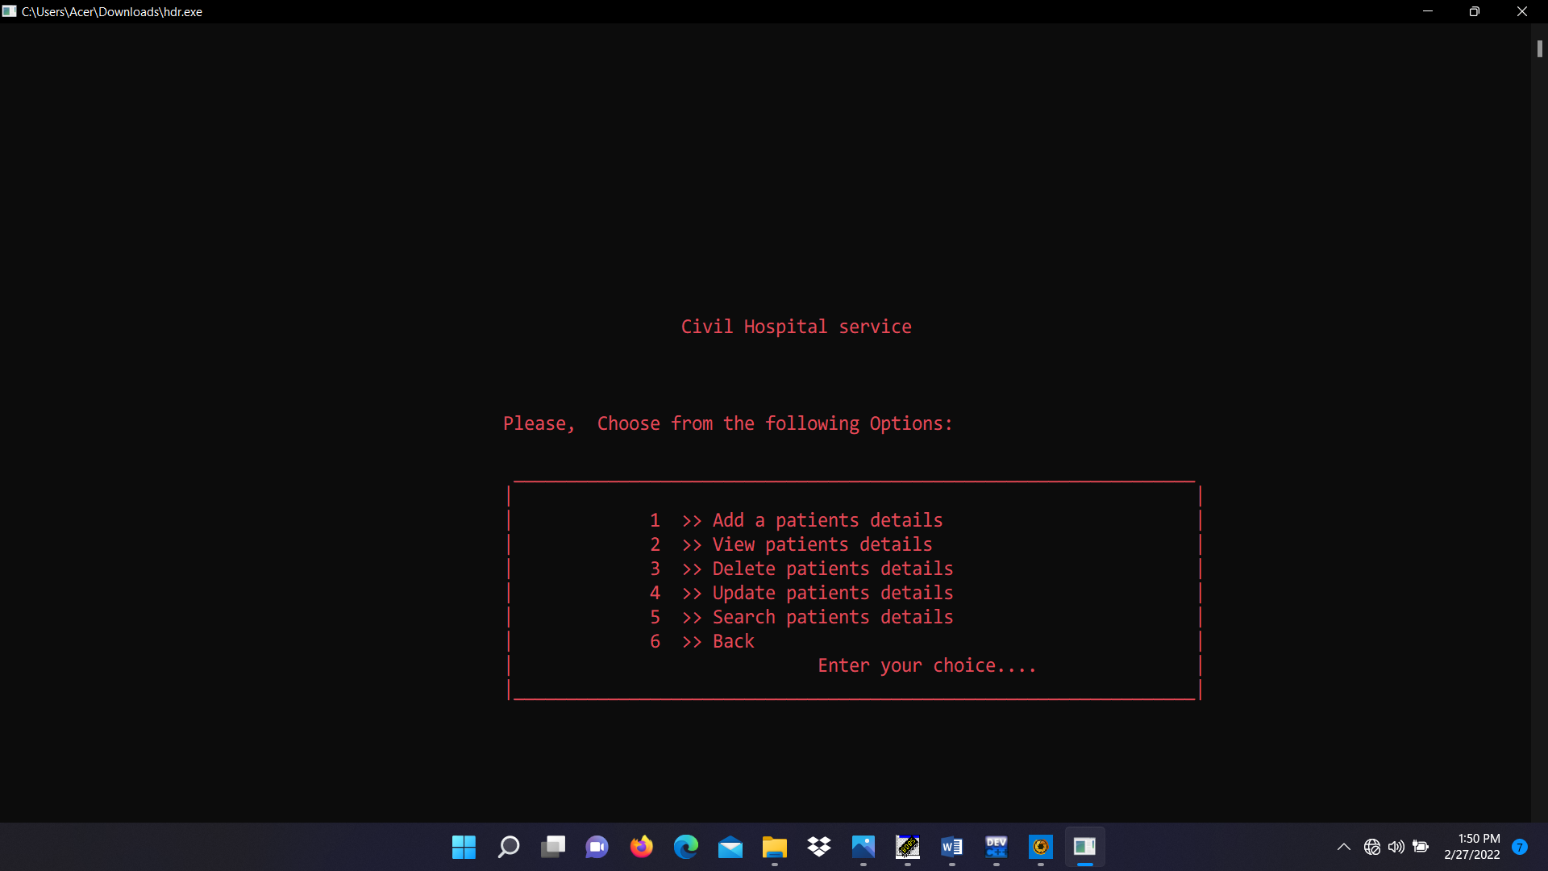

Fig: 5.11 Patient Detail Screen

**5.2 Conclusion**

In this system we had completed implementing a simple hospital management system which will store the data in file. It stores the hospital detail, staff detail, patient detail, attendance record and work schedule of the staff. We had completed this mini project with using C++ which we learned in our course.

**CHAPTER 7**

**REFERENCES**

**Journal:**

1. Author(s): Musa, A. Lancashire Bus. Sch., Univ. of Central Lancashire, Preston, UK
2. Yusuf,Y,Meckel. M. Systems and Informatics (ICSAI), 2012 International Conference

**Website:**

1. A detailed view of hospital management system, Available :

<https://mocdoc.in/blog/a-detailed-view-of-hospital-management-system> (Accessed 28 June 2021).

1. Hospital management software in Nepal, Available:

[https://deltatechnepal.com/business-apps/hospital- management](https://deltatechnepal.com/business-apps/hospital-%20%20management)-system (Accessed 15 July 2021).

1. Hospital information system, Available : <https://en.m.wikipedia.org/wiki/Hospital_information_system> (Accessed 15 July 2021).